# Unit 4 – Pandas Homework: PyCitySchools

In the study of $24.65 million budget allocated to 8 Charters and 7 Districts schools (totalling 15 schools), the correlation between the government budget and school performance, especially with reading and maths of our senior students is the main focus. All 15 schools test scores for year 9 to 12 were analysed. Using score of 70 as our passing benchmark, it was found that schools in the district has an overall passing rate of 65.17% with students performing better in Reading than Maths, measuring passing rate of 85.81% and 74.98% respectively. *Refer to Appendix* Figure 1: District Summary

Based purely on past test scores on reading and maths, it was identified that;

1. Each year levels shows a steady score between 80 – 81 for maths and 82.5 for reading. No one year level under or outperformed another year level.
2. Charters schools perform significantly better than District with the former with a high passing rate of 90.43%, while District schools are measured with a low of 53.67%. *Refer to Appendix* Figure 9: Scores by School Type
3. On average, $620.07 was budgeted per student however, 3 of our bottom-five-performing schools are amongst the highest recipient of the budget per student as well as larger schools with over 2,000 students for the 4-year level. *Refer to Appendix* Figure 4: Bottom Performing Schools (By % Overall Passing)
4. School size appears to be the biggest factor in determining student’s performance. Students in small to medium size school perform much better than schools with over 2,000 students. *Refer to Appendix* Figure 8: Scores by School Size

## Conclusion

Based on the data given, it was found that students in Medium Size schools of 1,000 to 2,000 students are overall better in Reading and Maths. Charter schools out performed District schools. Contrary to believe, budget value per student is not a driving factor for student’s performance. In this case, the number of students plays a major role in overall passing rate. To ensure optimal performance, it is recommended that schools should not exceed 2,000 students for year 9 to 12.

## Assumption

It is assumed that teacher-student ratio is the same among all the school studied.

# Appendix



Figure 1: District Summary

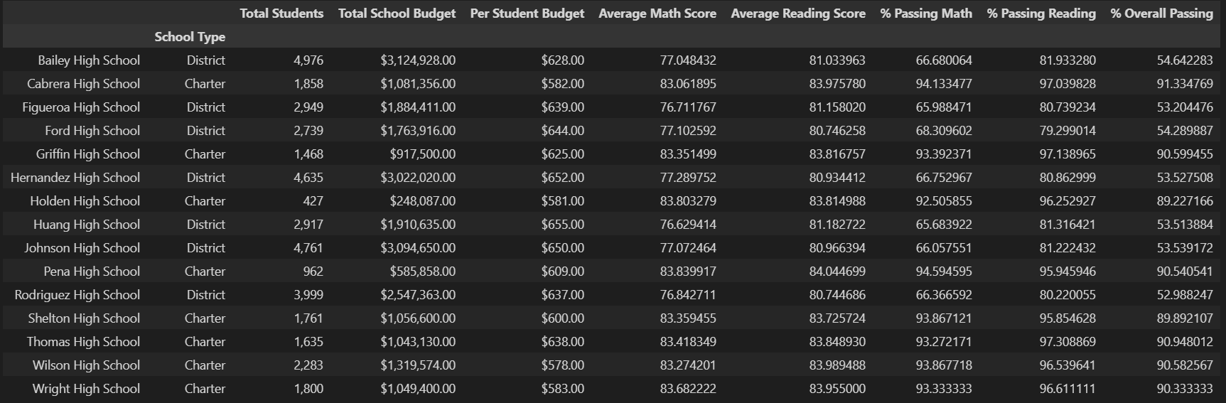

Figure 2: School summary

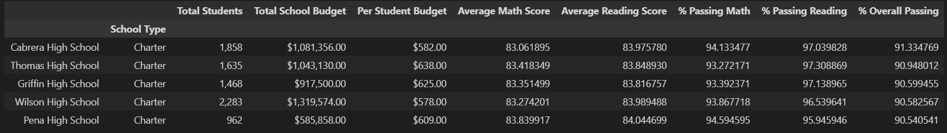

Figure 3: Top Performing Schools (By % Overall Passing)

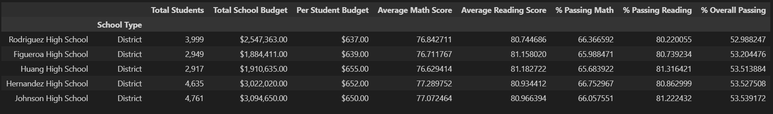

Figure 4: Bottom Performing Schools (By % Overall Passing)

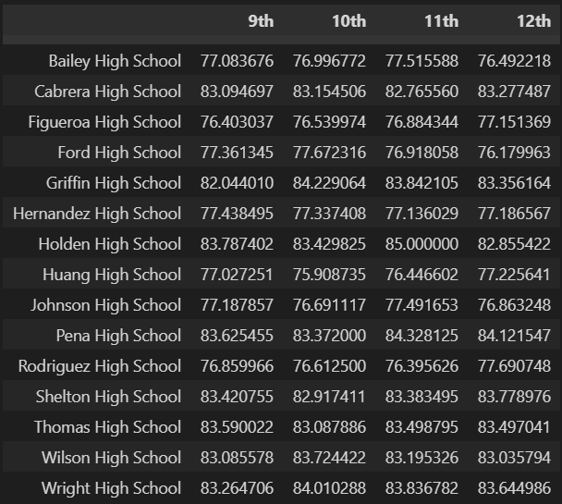

Figure 5: Math Scores by Grade

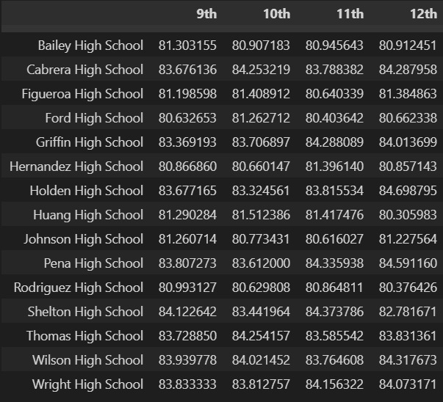

Figure 6: Reading Score by Grade

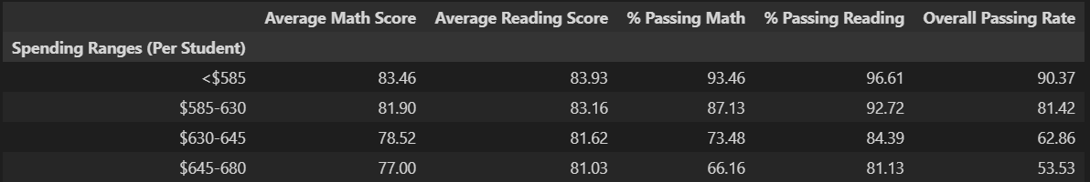

Figure 7: Scores by School Spending

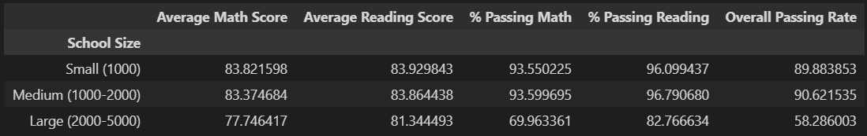

Figure 8: Scores by School Size

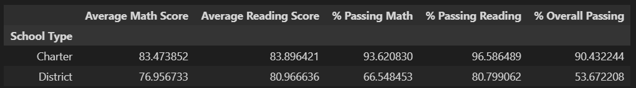

Figure 9: Scores by School Type